Exercise – 1 B

SANDRA MARIA TONY

RA1911026010045

CSE-K1(AI-ML)

**AIM:**

Implementation of Lexical Analysis program to identify:

* Keywords
* Operators
* Valid Identifiers
* Invalid Identifiers
* Integers

**PROCEDURE:**

* Open the compiler
* Write the code
* Compile the code
* Execute the code
* Verify the output.

**SOURCE CODE IN C:**

#include <stdbool.h>

#include <stdio.h>

#include <string.h>

#include <stdlib.h>

bool isValidDelimiter(char ch) {

   if (ch == ' ' || ch == '+' || ch == '-' || ch == '*' ||

   ch == '/' || ch == ',' || ch == ';' || ch == '>' ||

   ch == '<' || ch == '=' || ch == '(' || ch == ')' ||

   ch == '[' || ch == ']' || ch == '{' || ch == '}')

   return (true);

   return (false);

}

bool isValidOperator(char ch){

   if (ch == '+' || ch == '-' || ch == '*' ||

   ch == '/' || ch == '>' || ch == '<' ||

   ch == '=')

   return (true);

   return (false);

}

// Returns 'true' if the string is a VALID IDENTIFIER.

bool isvalidIdentifier(char* str){

   if (str[0] == '0' || str[0] == '1' || str[0] == '2' ||

   str[0] == '3' || str[0] == '4' || str[0] == '5' ||

   str[0] == '6' || str[0] == '7' || str[0] == '8' ||

   str[0] == '9' || isValidDelimiter(str[0]) == true)

   return (false);

   return (true);

}

bool isValidKeyword(char* str) {

   if (!strcmp(str, "if") || !strcmp(str, "else") || !strcmp(str, "while") || !strcmp(str, "do") ||    !strcmp(str, "break") || !strcmp(str, "continue") || !strcmp(str, "int")

   || !strcmp(str, "double") || !strcmp(str, "float") || !strcmp(str, "return") || !strcmp(str,    "char") || !strcmp(str, "case") || !strcmp(str, "char")

   || !strcmp(str, "sizeof") || !strcmp(str, "long") || !strcmp(str, "short") || !strcmp(str, "typedef") || !strcmp(str, "switch") || !strcmp(str, "unsigned")

   || !strcmp(str, "void") || !strcmp(str, "static") || !strcmp(str, "struct") || !strcmp(str, "goto"))

   return (true);

   return (false);

}

bool isValidInteger(char* str) {

   int i, len = strlen(str);

   if (len == 0)

   return (false);

   for (i = 0; i < len; i++) {

      if (str[i] != '0' && str[i] != '1' && str[i] != '2'&& str[i] != '3' && str[i] != '4' && str[i] != '5'

      && str[i] != '6' && str[i] != '7' && str[i] != '8' && str[i] != '9' || (str[i] == '-' && i > 0))

      return (false);

   }

   return (true);

}

bool isRealNumber(char* str) {

   int i, len = strlen(str);

   bool hasDecimal = false;

   if (len == 0)

   return (false);

   for (i = 0; i < len; i++) {

      if (str[i] != '0' && str[i] != '1' && str[i] != '2' && str[i] != '3' && str[i] != '4' && str[i]       != '5' && str[i] != '6' && str[i] != '7' && str[i] != '8'

      && str[i] != '9' && str[i] != '.' || (str[i] == '-' && i > 0))

      return (false);

         if (str[i] == '.')

      hasDecimal = true;

   }

   return (hasDecimal);

}

char* subString(char* str, int left, int right) {

   int i;

   char* subStr = (char*)malloc( sizeof(char) * (right - left + 2));

   for (i = left; i <= right; i++)

      subStr[i - left] = str[i];

   subStr[right - left + 1] = '\0';

   return (subStr);

}

void detectTokens(char* str) {

   int left = 0, right = 0;

   int length = strlen(str);

   while (right <= length && left <= right) {

      if (isValidDelimiter(str[right]) == false)

      right++;

      if (isValidDelimiter(str[right]) == true && left == right) {

         if (isValidOperator(str[right]) == true)

         printf("Valid operator : '%c'\n", str[right]);

         right++;

         left = right;

      } else if (isValidDelimiter(str[right]) == true && left != right || (right == length && left !=       right)) {

         char* subStr = subString(str, left, right - 1);

         if (isValidKeyword(subStr) == true)

            printf("Valid keyword : '%s'\n", subStr);

         else if (isValidInteger(subStr) == true)

            printf("Valid Integer : '%s'\n", subStr);

         else if (isRealNumber(subStr) == true)

            printf("Real Number : '%s'\n", subStr);

         else if (isvalidIdentifier(subStr) == true

            && isValidDelimiter(str[right - 1]) == false)

         printf("Valid Identifier : '%s'\n", subStr);

         else if (isvalidIdentifier(subStr) == false

            && isValidDelimiter(str[right - 1]) == false)

         printf("Invalid Identifier : '%s'\n", subStr);

         left = right;

      }

   }

   return;

}

int main(){

   char str[100] = "float x = a + 1b; ";

   printf("The Program is : '%s' \n", str);

   printf("All Tokens are : \n");

   detectTokens(str);

   return (0);

}

**CODE SCREENSHORT:**

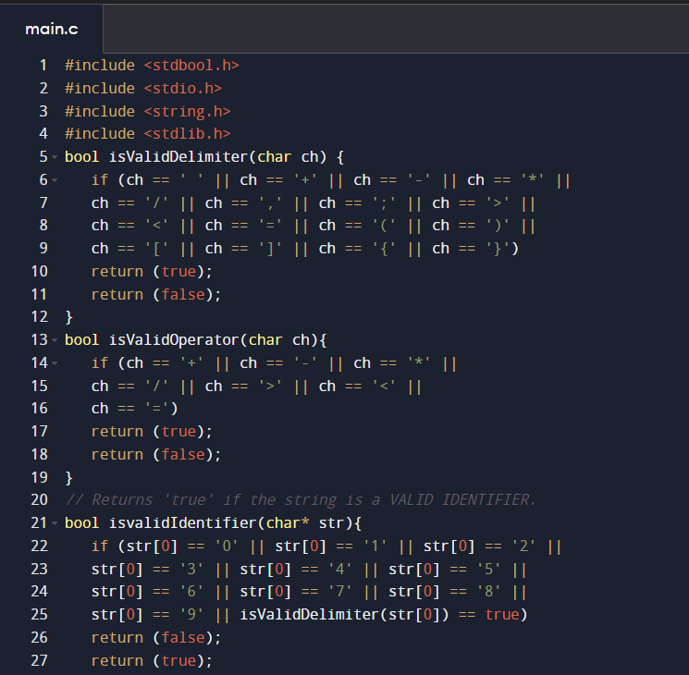

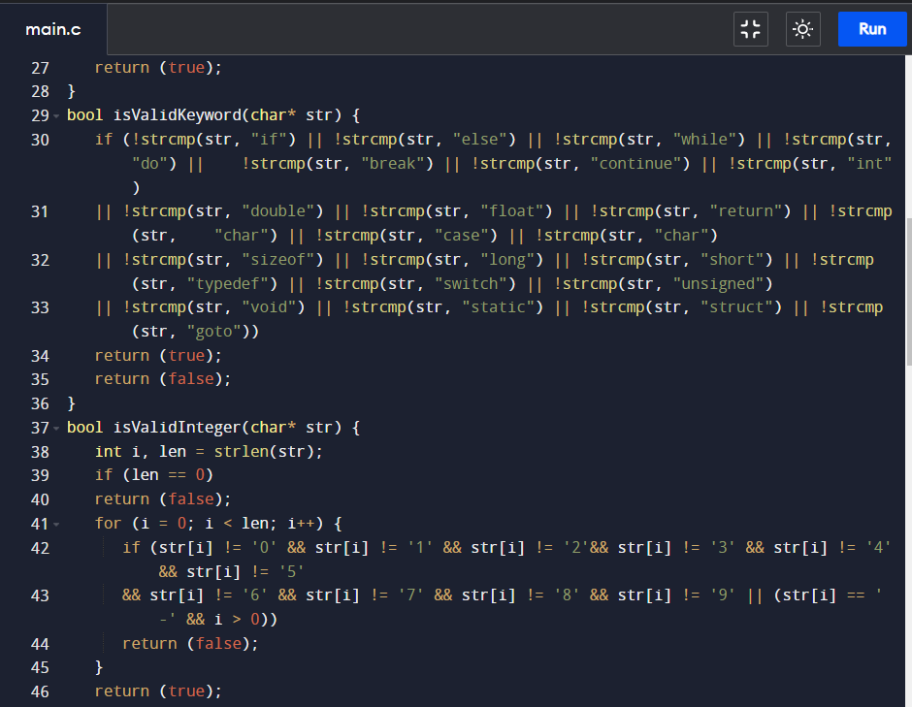

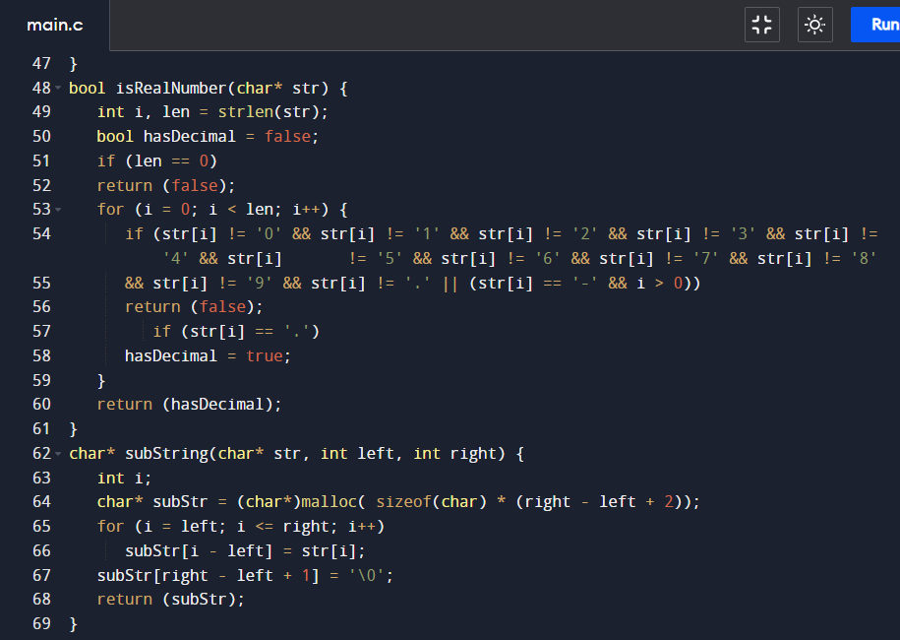

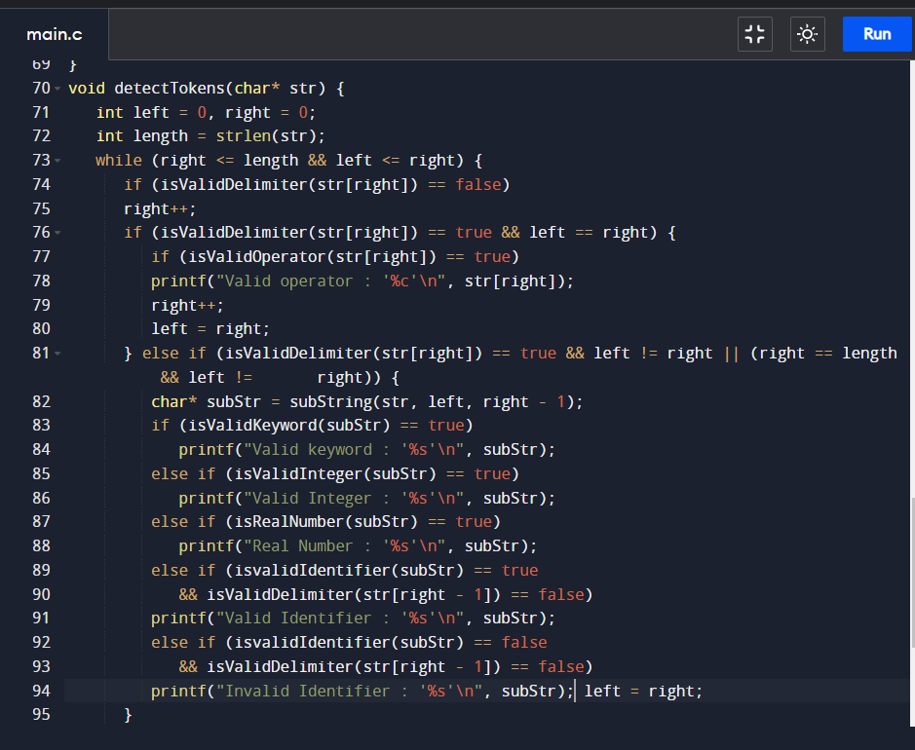

**INPUT 1:**

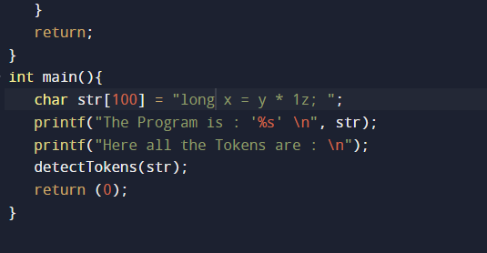 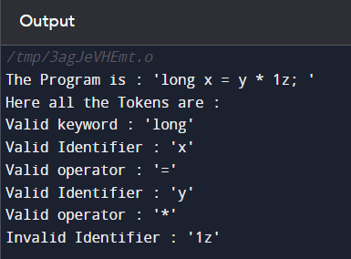

**INPUT 2:**

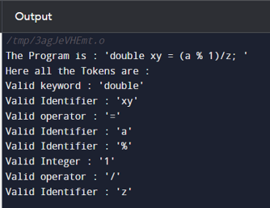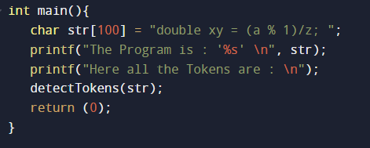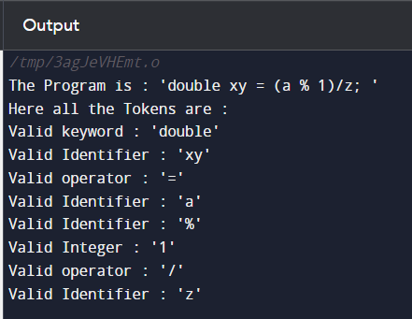

**INPUT 3:**

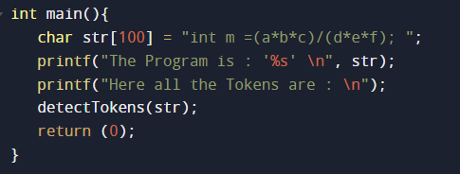 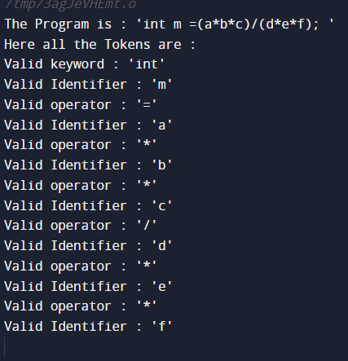

**INPUT 4:**

